Data Visualization and Communication
Final Project Report

Project Name:
MyBestHospital.com

Project Participants:
Christopher Walker
Rahul Bansal
Joe Morales
Lisa Kirch

Project URL:
http://groups.ischool.berkeley.edu/mybesthospital/

Code Repository URL:
https://github.com/jmorales4/W209-RJCL

Who did what:

Task | Chris | Rahul | Joe | Lisa
User Interviews | 25% | 25% | 25% | 25%
Data Cleaning | 40% | 20% | 40%
Ranking Formula |  | 100%
Graphic Design | 40% | 20% | 20% | 20%
Coding | 30% (D3 JavaScript - InfoBox) | 5% (About) | 30% (Google map, Sliders) | 25% (D3 JavaScript Horizontal Stacked Bar Chart)
Usability Testing | 30% | 20% | 20% | 30%
Final presentation | 25% | 25% | 25% | 25%
Documentation |  | 20% |  | 80%
Final paper | 20% | 20% | 20% | 40%

Additional Notes:
After the usability testing of 7 users, we added an introductory tour of the website. This was done to address an issue that arose in usability testing where it was not clear how the sliders, filters, and scoring scale worked. In addition, the same numbers used in the map are lined up next to the hospital name in the chart. The results of the Silverback testing conducted by Chris Walker can be found at https://www.dropbox.com/l/mClRHA1m8LAGr6eI8xFlPo.

Figure 1 - User Tour

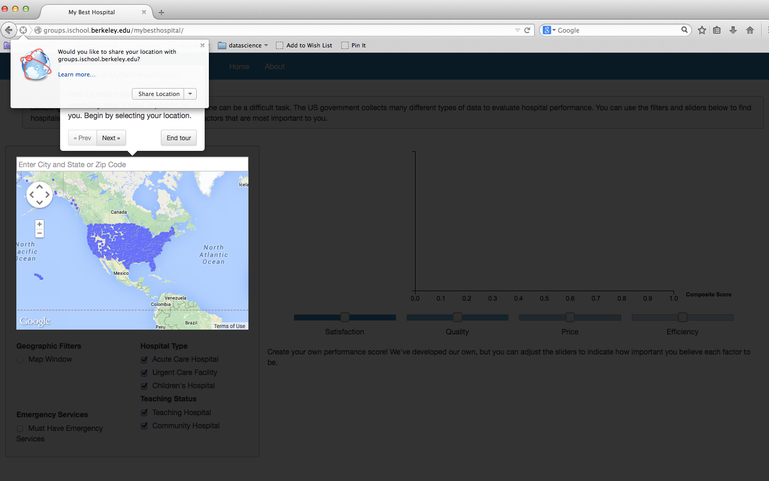

Figure 2 – User Tour

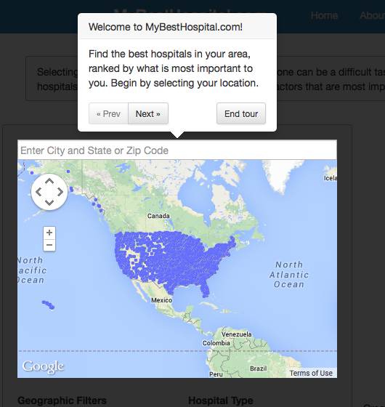

Figure 3 – User Tour

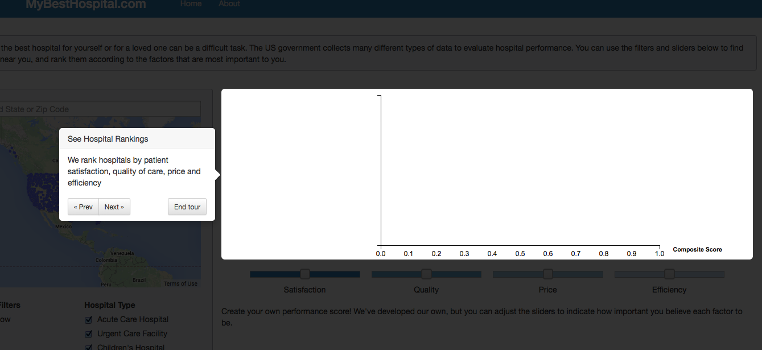

Figure 4 – User Tour

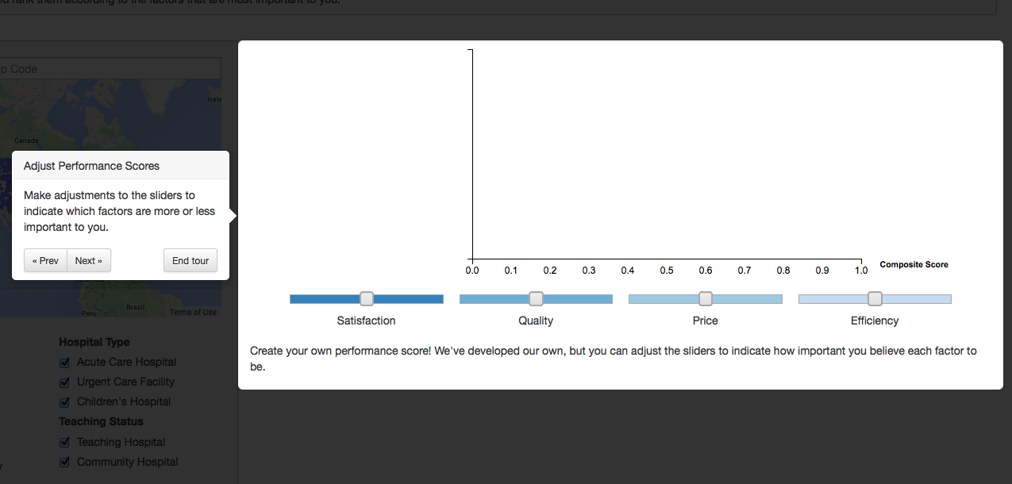

Figure 5 – User Tour

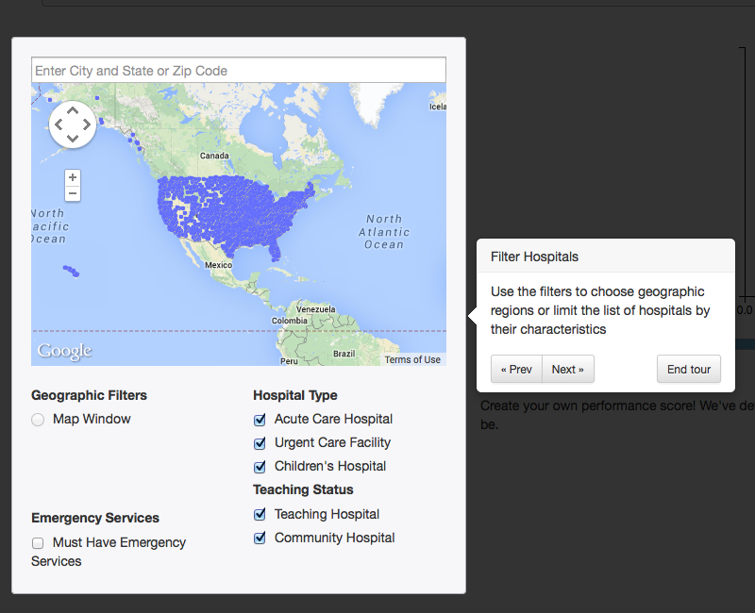

Figure 6 – User Tour

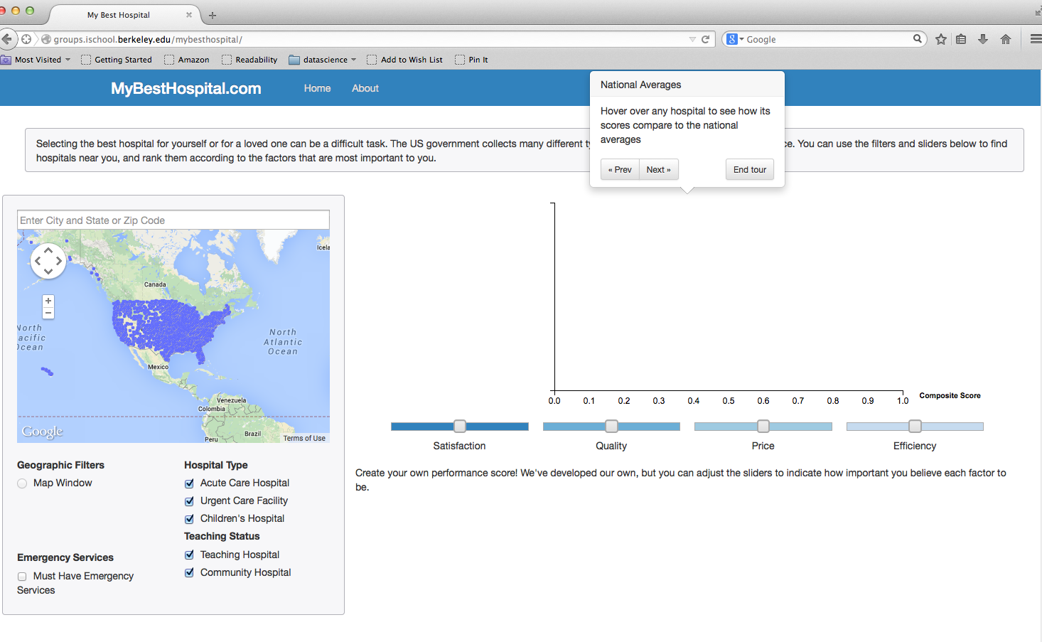

Figure 7 – User Tour

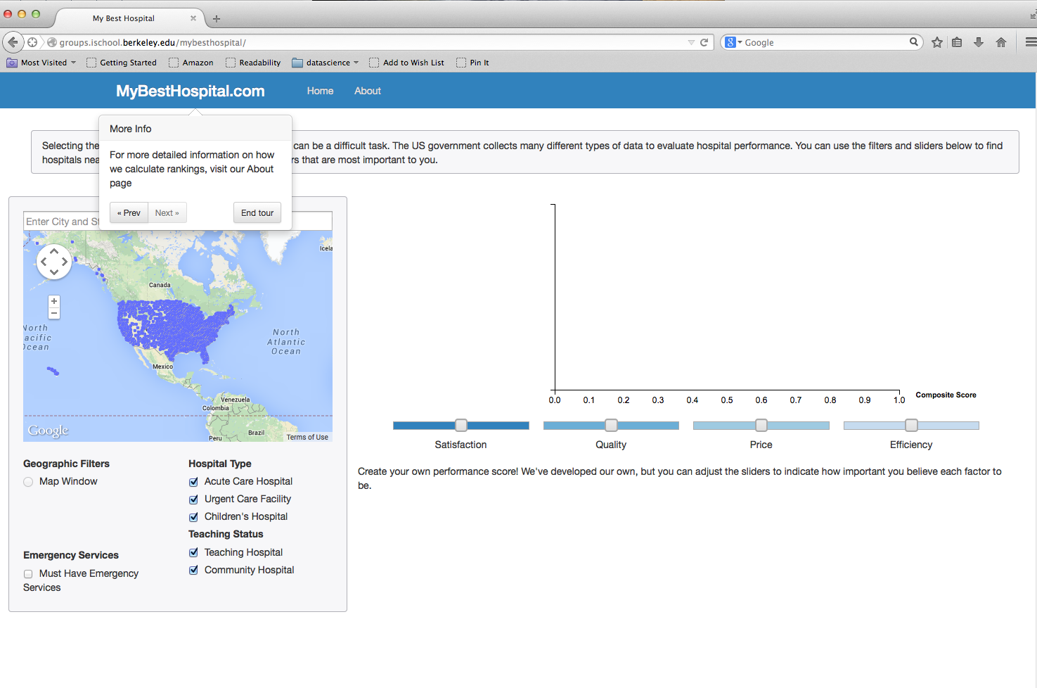

Figure 8 – Matching Numbers Between Map and Chart

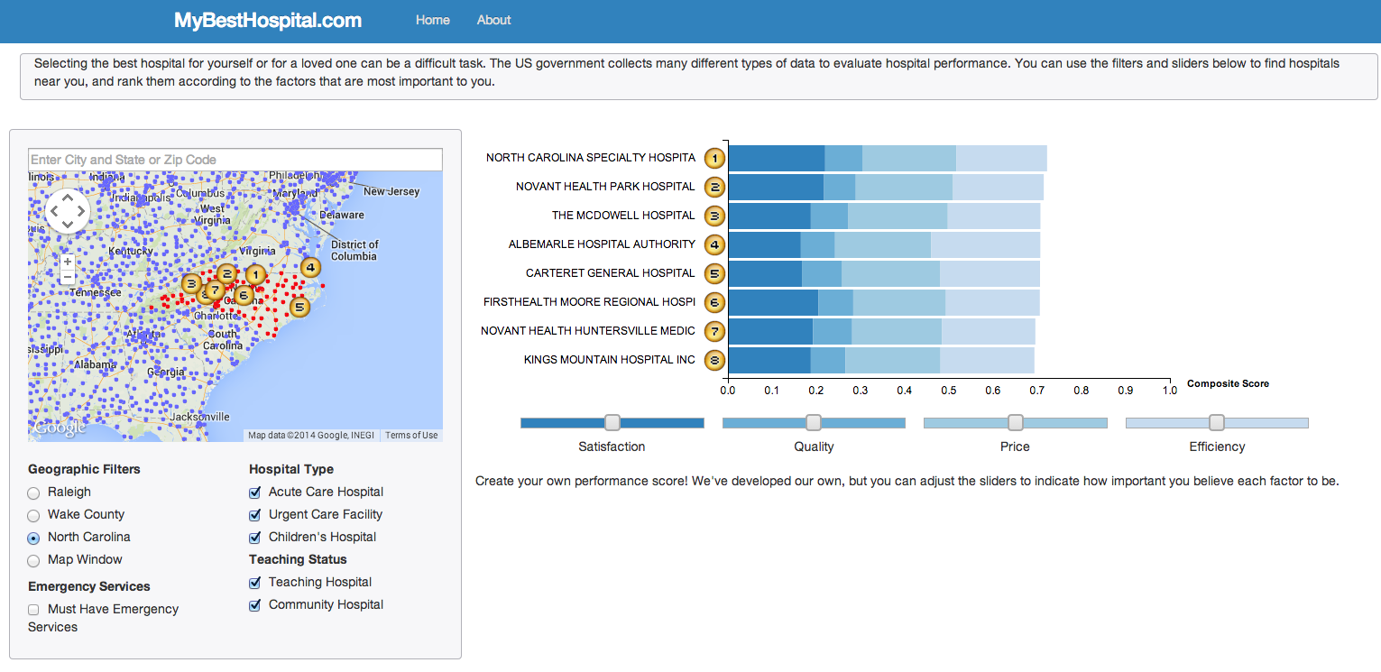

Additional Usability Testing

1) Code Validation - We validated our code using the W3C Markup Validation Service.

Figure 9 – Results W3C Markup Validation

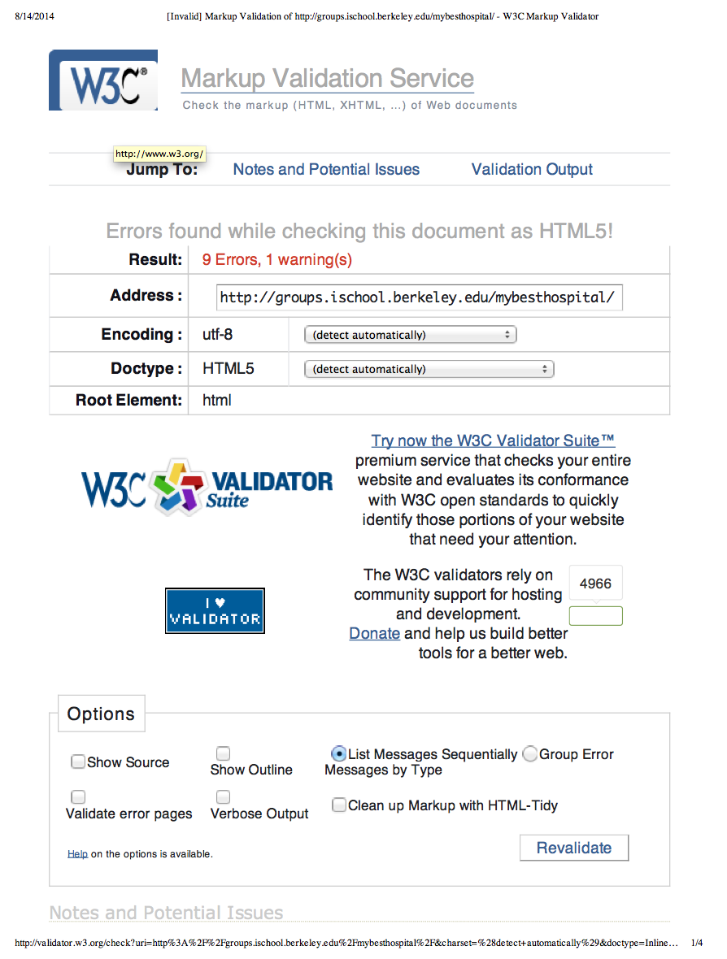

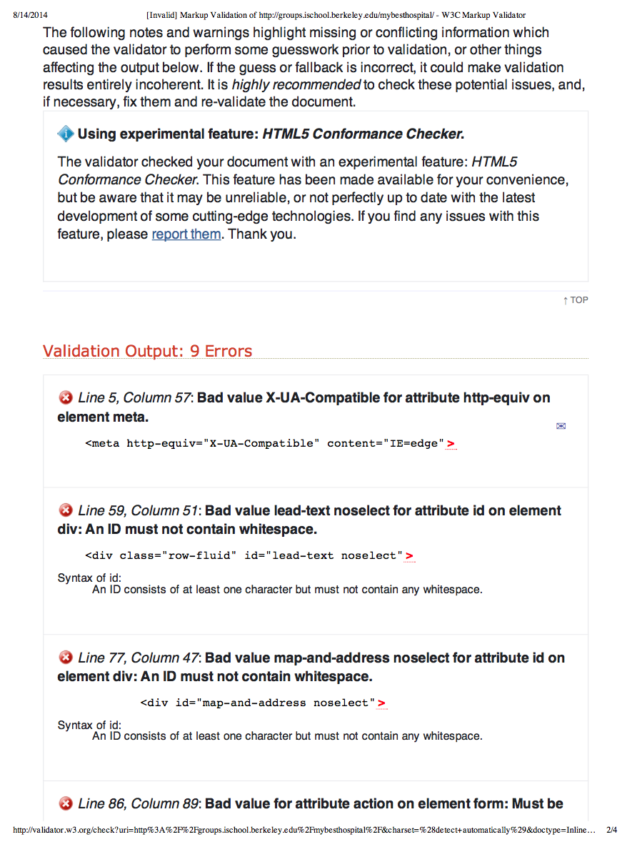
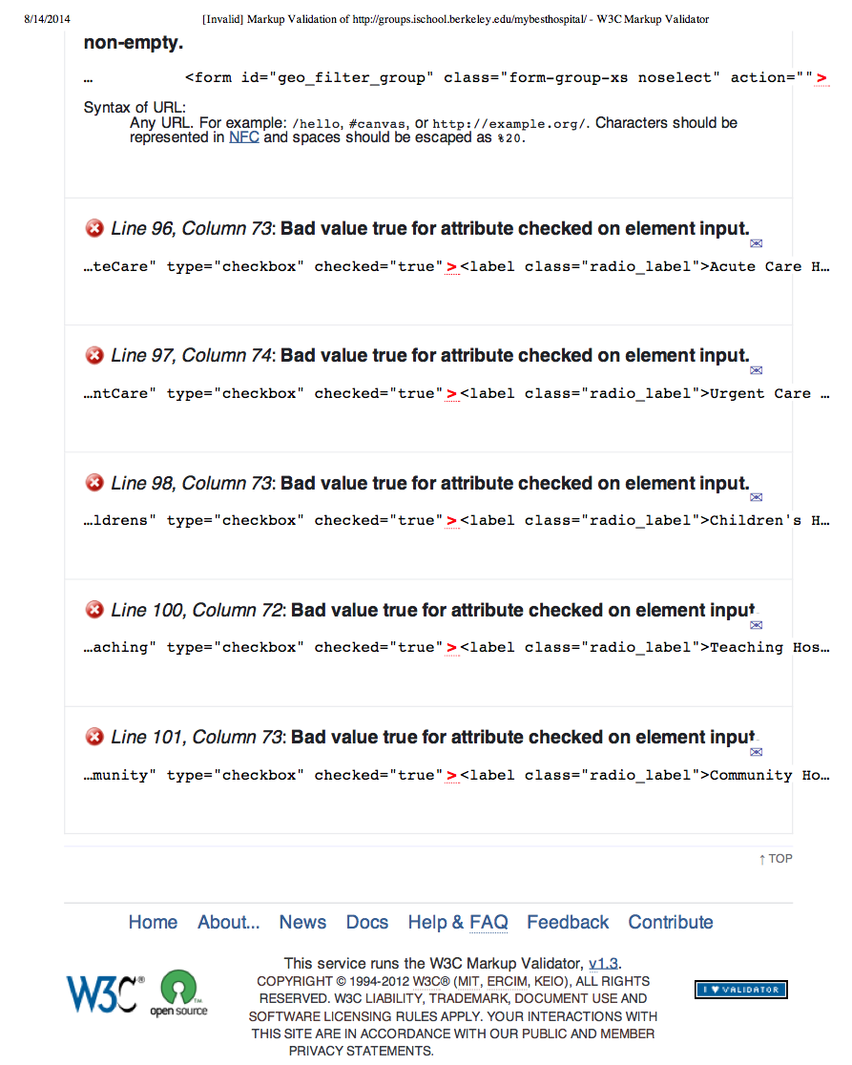

2) Web Site Performance - We tested our website’s performance using webpagetest.org using several locations and browsers.

Figure 10 – Testing Web Performance from Dublin, Ireland using IE9

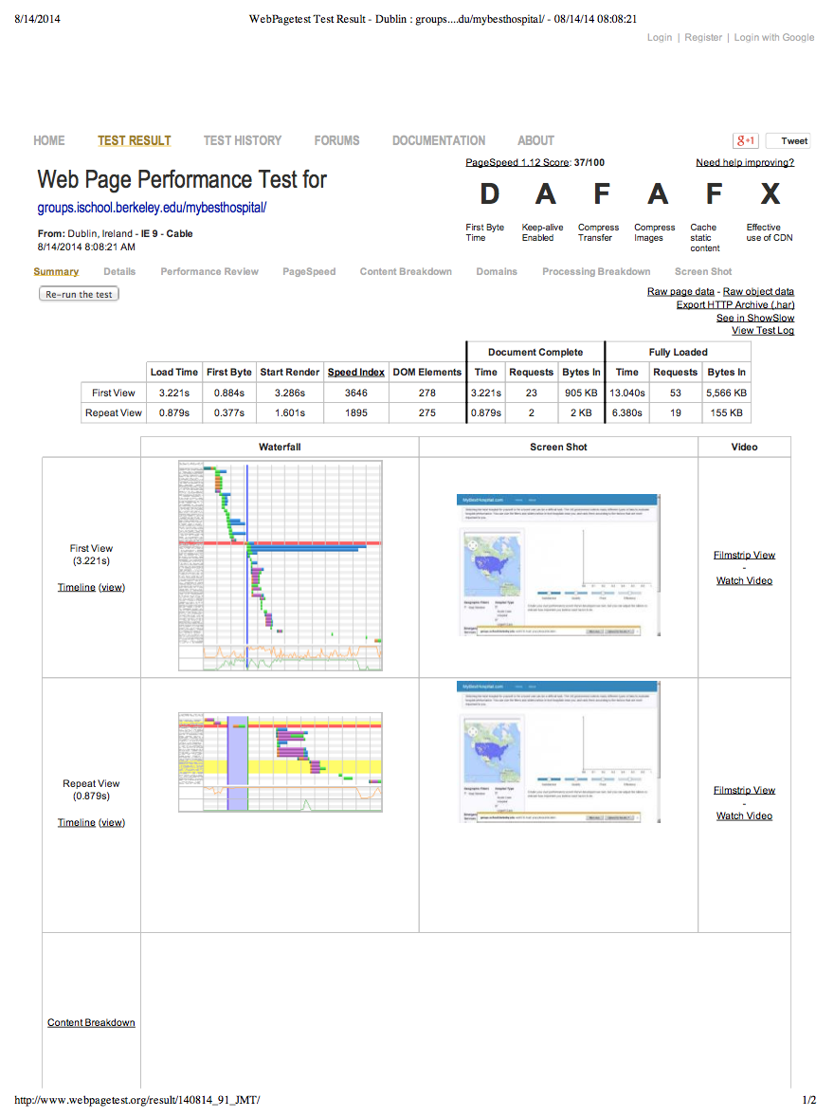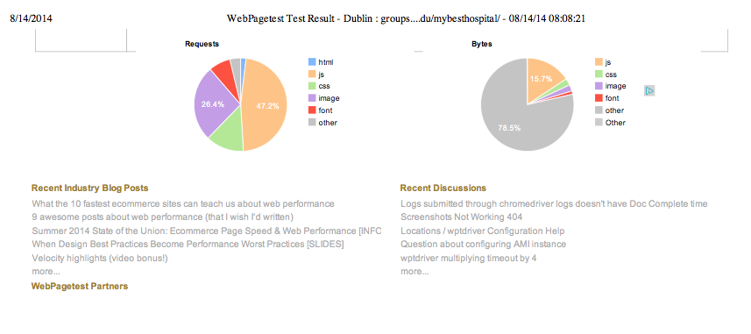

Figure 11 – Testing Web Performance from Dulles, VA using IE9
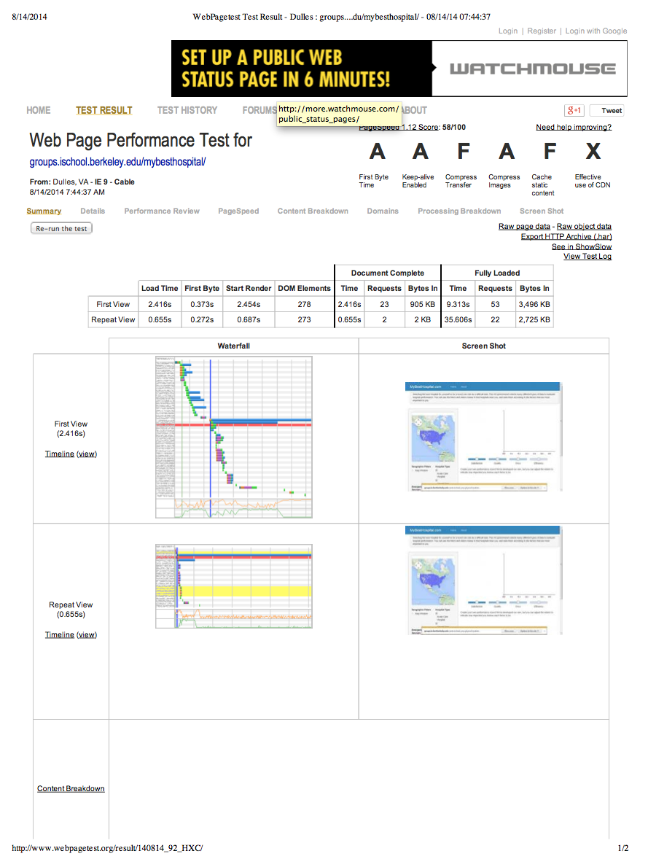

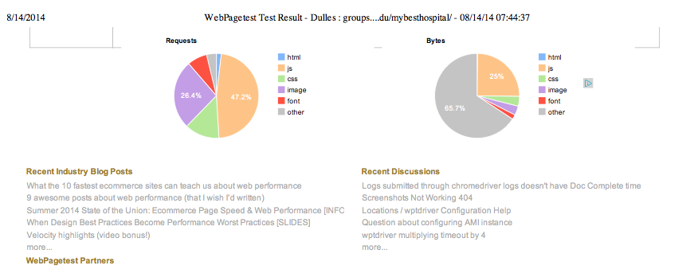

Figure 12 – Testing Web Performance from San Jose, CA using Firefox

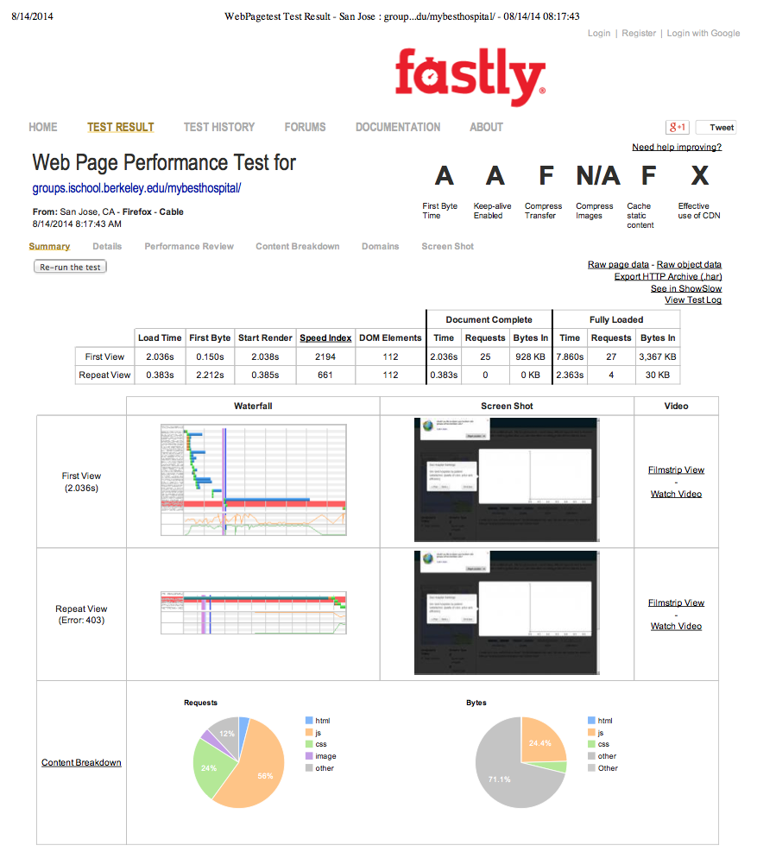

Figure 13 – Testing Web Performance from Wellington, New Zealand using Chrome
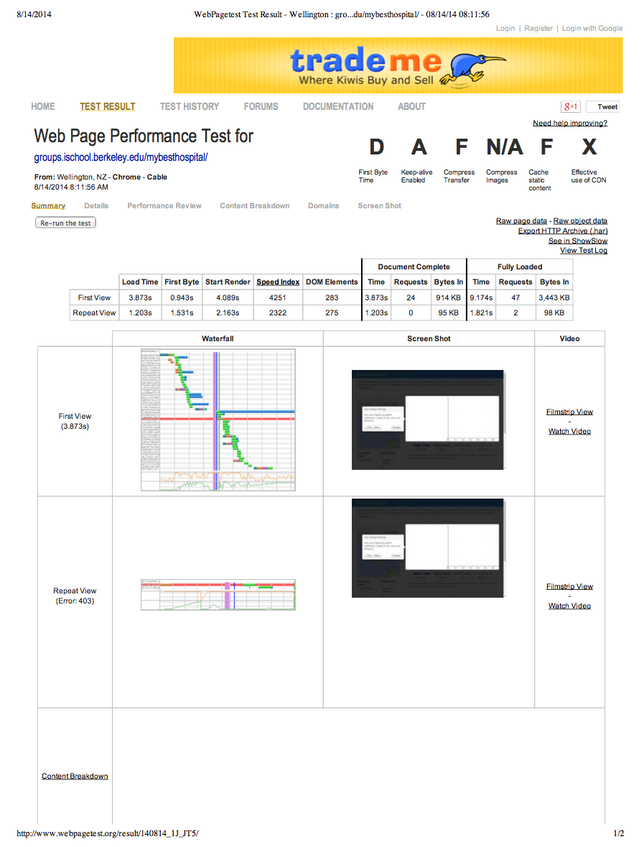

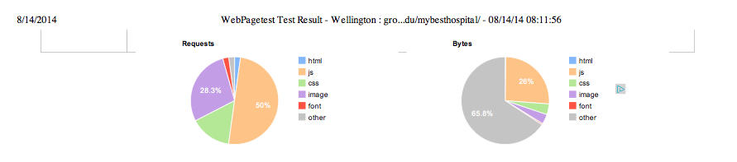

3) Readability - We testing the readability of our About page using read-able.com.

Figure 14 – Readability Test Results

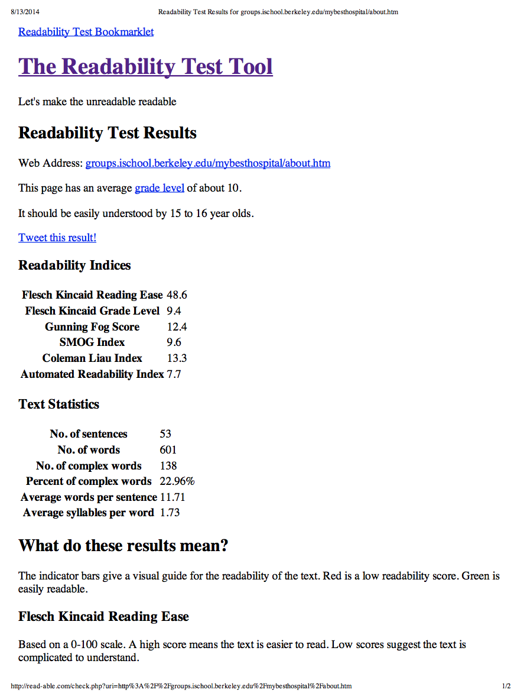
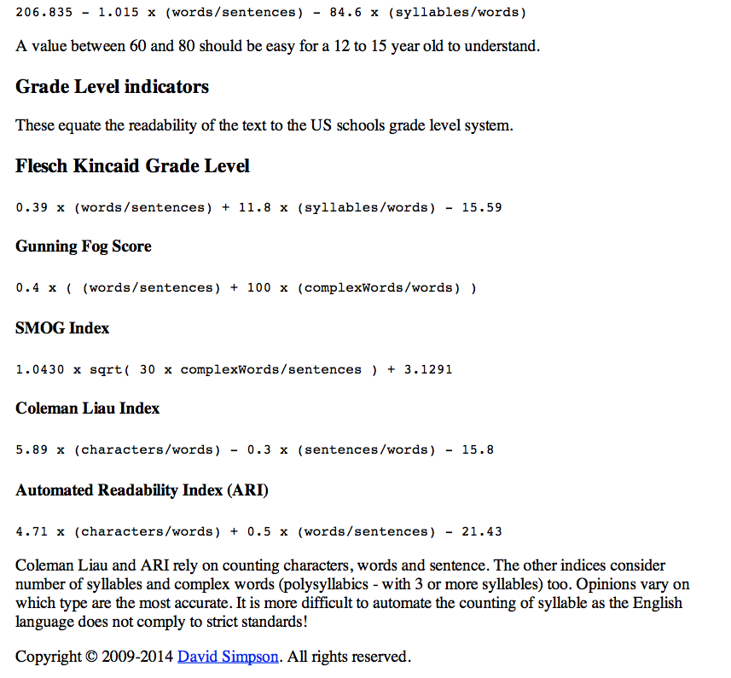

We also used Words Count for some statistics on our About page.

Figure 15 – WordsCount: Statistics

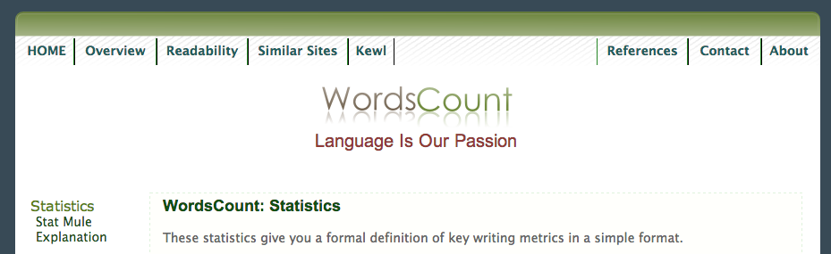
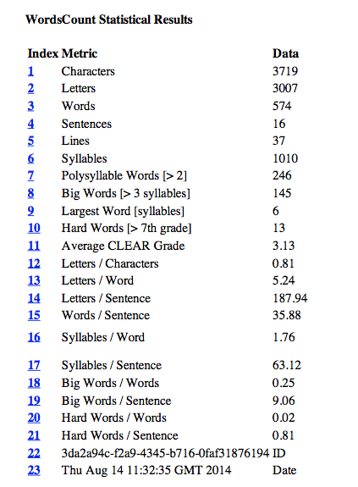
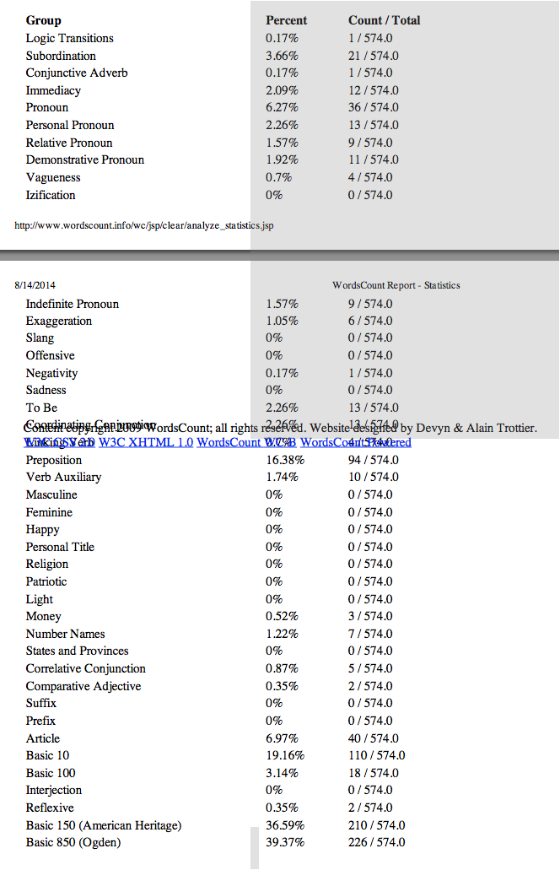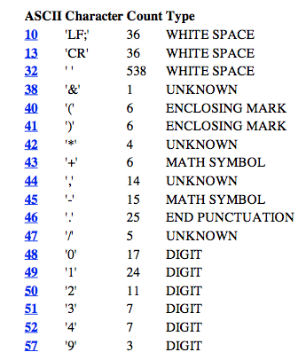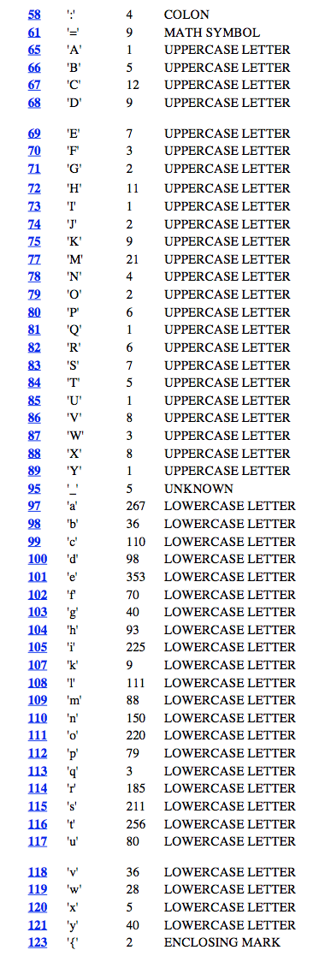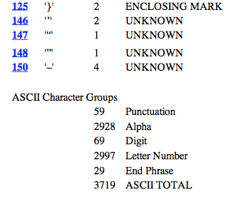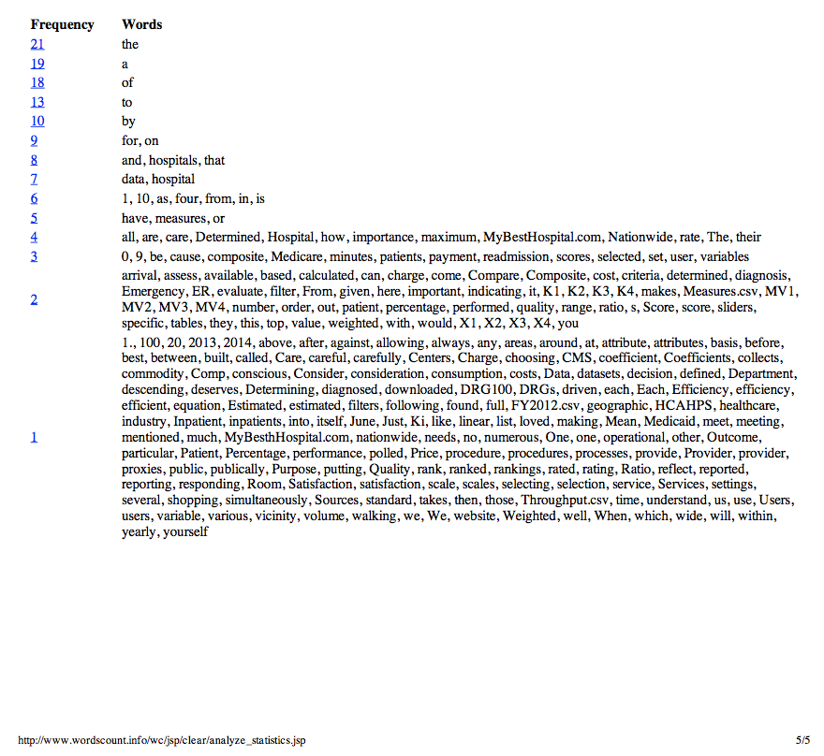

4) Visual Accessibility - We analyzed the color contrast of our website using checkmycolours.

Figure 16 – Results Color Contrast Analysis
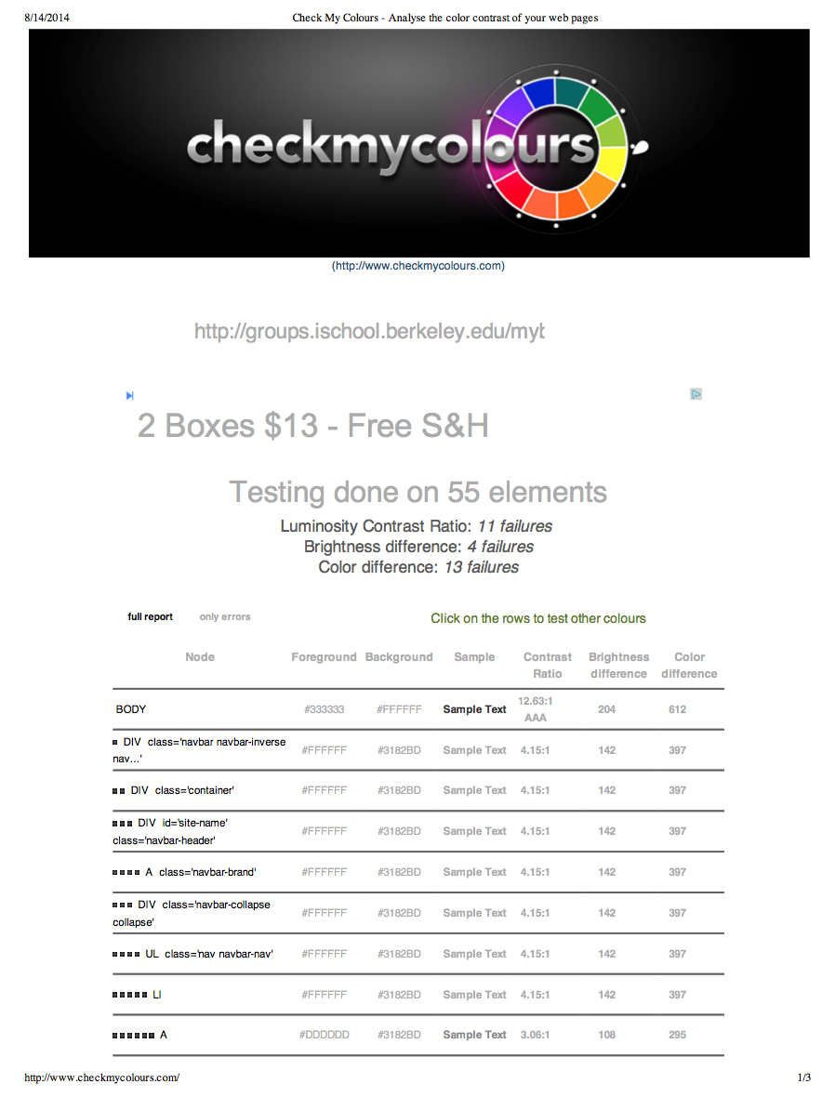

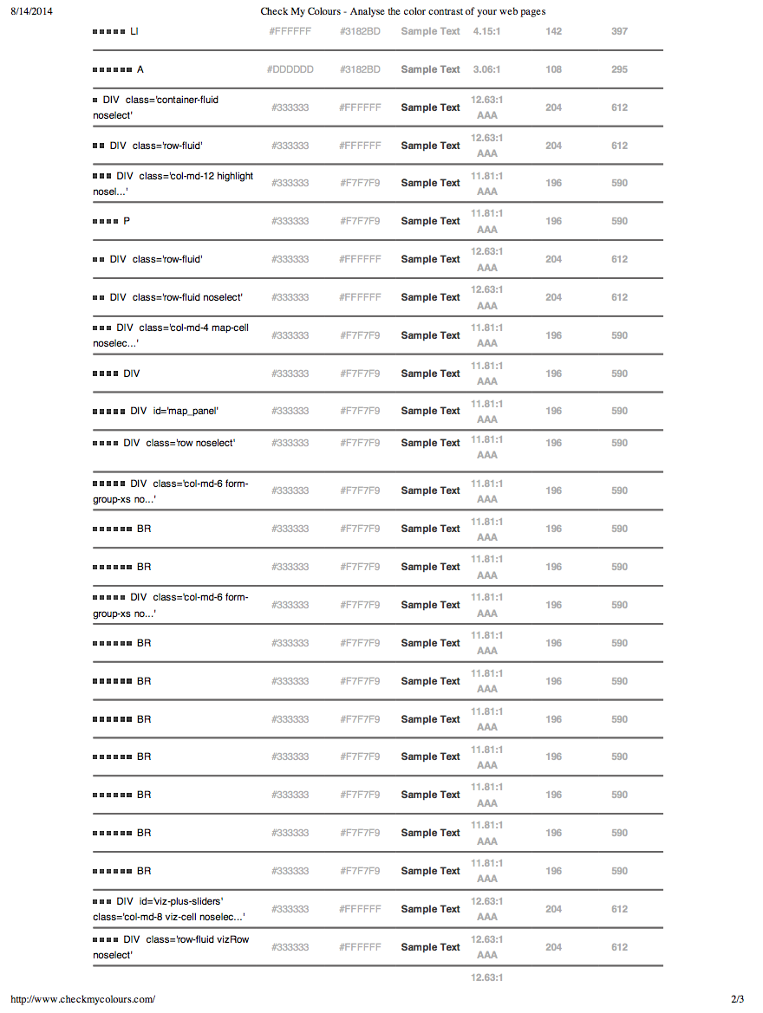

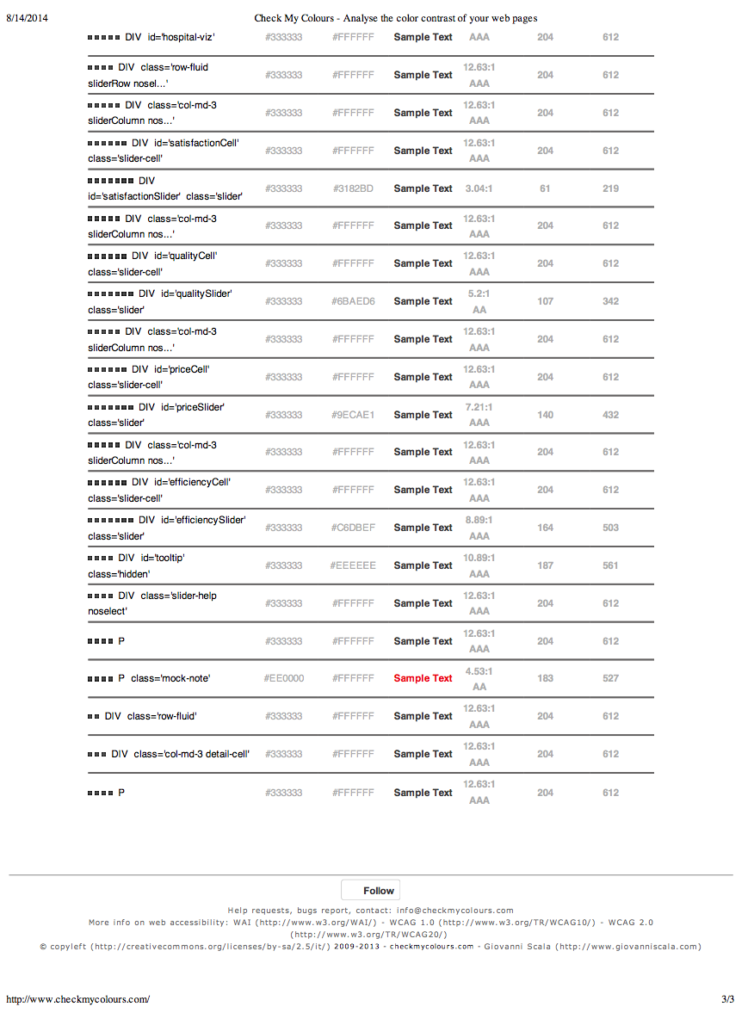

We planned to test the website for color blindness, but the website http://www.vischeck.com was unavailable for testing.

To get a feel for how our site looked in 50 different browsers running on Linux, Windows, and Mac environments, we used Browser Shots. (Note: Only a few screen shots are included here, but all files are available in zipped format at https://learn.datascience.berkeley.edu/local/files/lib/download.php?id=4055&userid=112 and https://learn.datascience.berkeley.edu/local/files/lib/download.php?id=4064&userid=112). The application was developed using both PCs and Macs.

Figure 17 – Epiphany 3.6.1 Running on Ubuntu 9.10 View of MyBestHospital

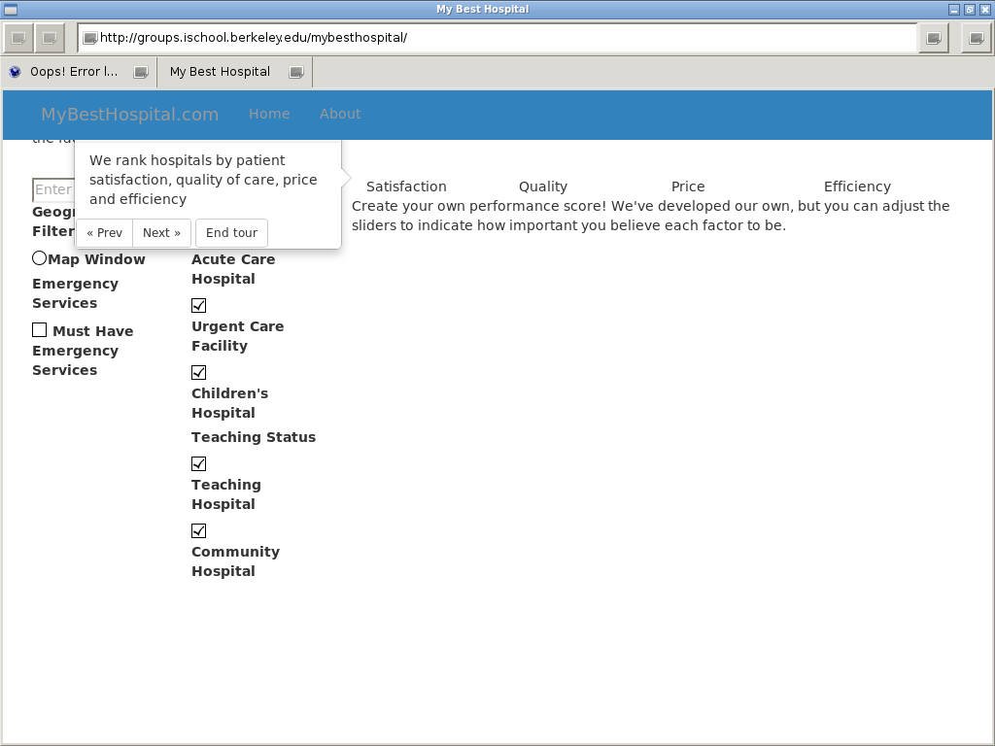

Figure 18 – Opera 12.02 Running on Debian 6.0 View of MyBestHospital

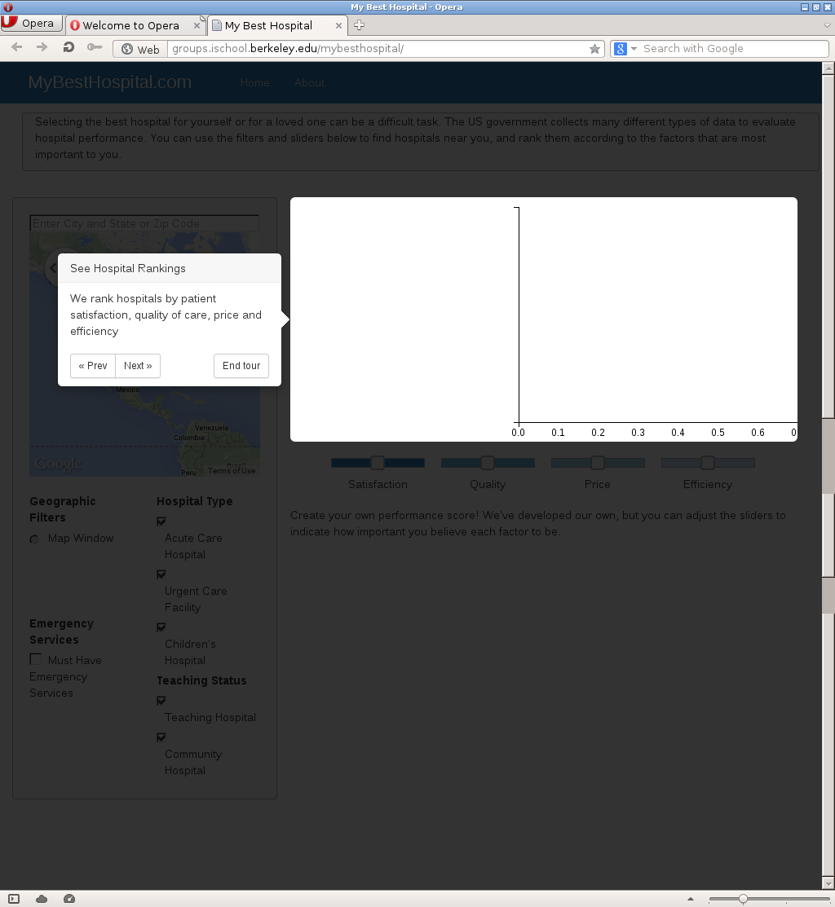

Figure 19 – Safari 7.0.6 Running on Mac OSX 10.80 View of MyBestHospital

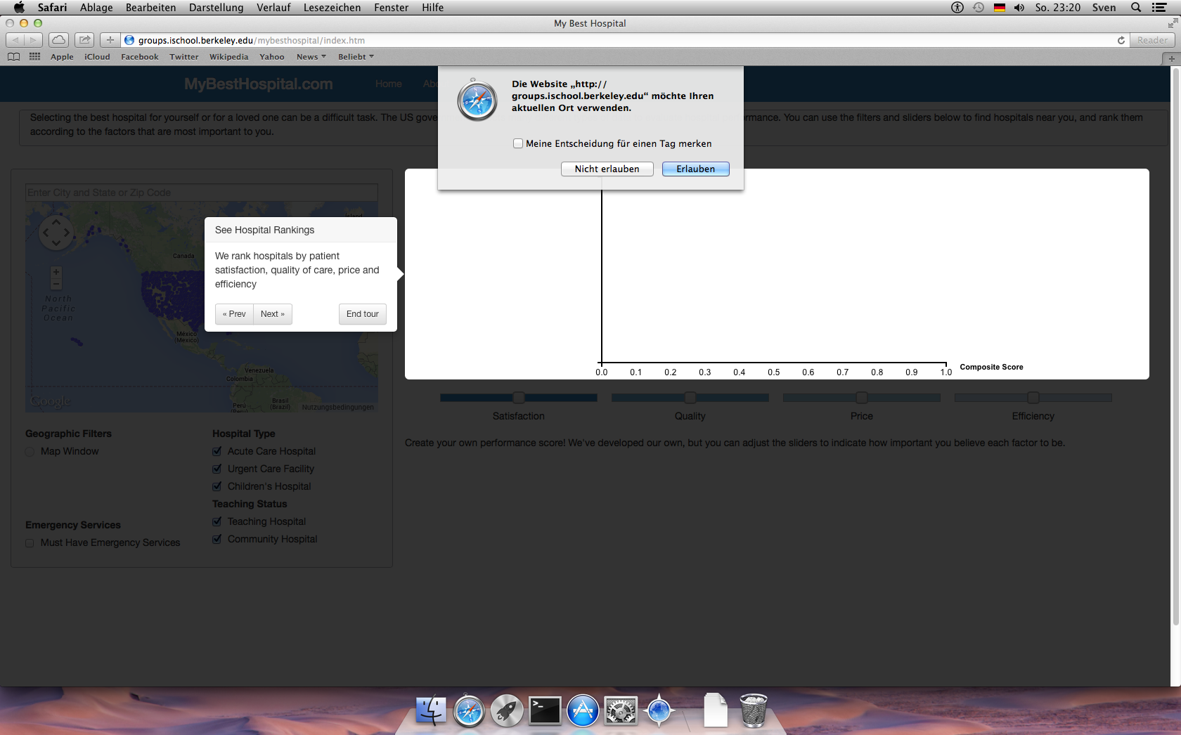

Figure 20 – Chrome 26.0.1410.43 Running on Windows 2008 r2 View of MyBestHospital

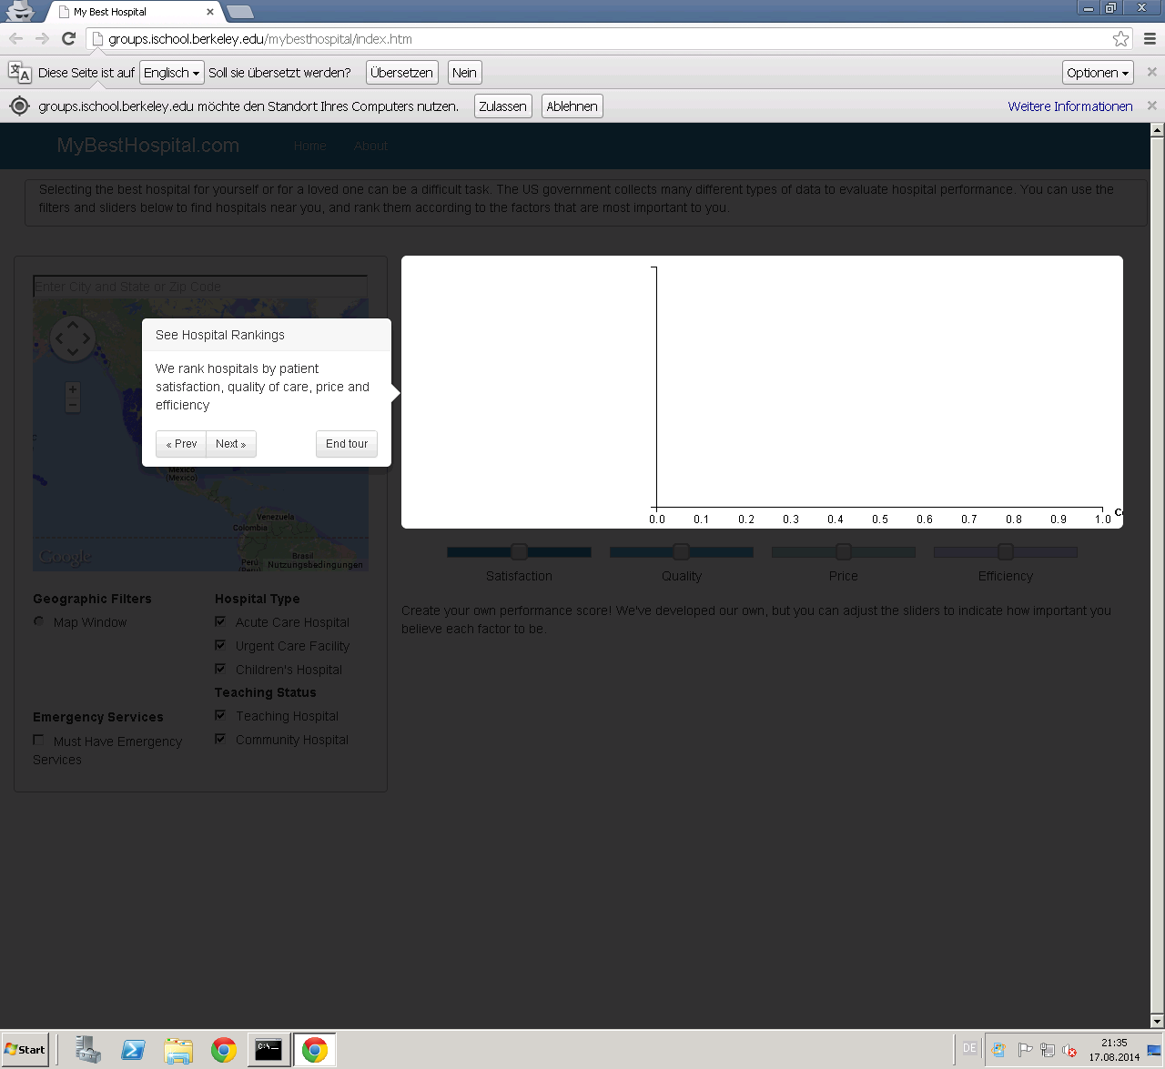

Iterations of MyBestHospital.com:

Figure 21 – MyBestHospital.com Project Iterations

